The next several videos will be devoted to SQL Server Monitoring and the tools that come with the SQL Server

We will be discussing the following tools

* Windows Task Manager
* SQL Activity monitor
* SQL Performance Monitor
* SQL Database Management Views (DMV)
* Stored Procedures
* SQL Profiler

[Activity Monitor in SQL Server](http://www.sqlservercurry.com/2013/04/activity-monitor-in-sql-server.html)

|  |  |
| --- | --- |
|  |  |

The primary function of the Activity Monitor is to allow the DBA to quickly view any potential performance issues in the server, network or the database. If any contentions are occurring between SPIDs, this is where the DBA can kill the process

Viewing the Activity Monitor Dashboard you will notice four graphs which can help identity any abnormal activity in the Database. Note that the refresh rate for each graph is 10 seconds; however it can be changed by right clicking on the graph

Here is what he Activity monitor looks like:

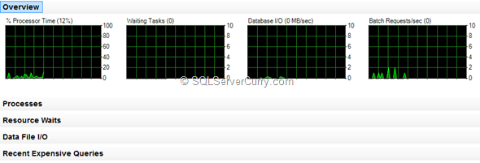

This dashboard also contain four panes where you can view more detailed information about each process inside the server

**Processor Time:**

The Processes pane gives information on what processes are running and what resources are being utilized etc. You can right click this and view the Kill, Profiler, and Detail options

**Waiting Tasks:**

The number of tasks that are waiting for processor, I/O, or memory resources. The Resource Waits pane details the processes waiting for other resources on the server

**Database I/O: (Input/Output)**

Information on data and log files for both system and user defined databases. Provides information on such things as the transfer rate in MB/Sec, data from memory to disk, disk to memory, or disk to disk. This allow the DBA to quickly view what is causing I/O contention

**Batch Requests/sec:**

This pane show the number of batches being received,

Expensive queries running, and [Find the Most Time Consuming Code in your SQL Server Database](http://www.sqlservercurry.com/2010/07/find-most-time-consuming-code-in-your.html). If you right click this pane, you can view the execution plan option

**The various panes info**

The Processes pane shows the information about the currently running processes on the SQL databases, who runs them, and from which application. Hover over each header to show tool tip

Session ID – or SPID is a unique value assigned by Database Engine to every user connection.

User Process – 1 for user processes, 0 for system processes.

Task State – the task state, blank for tasks in the runnable and sleeping state

PENDING: Waiting for a worker thread.  
RUNNABLE: Runnable, but waiting to receive a quantum.  
RUNNING: Currently running on the scheduler.  
SUSPENDED: Has a worker, but is waiting for an event.  
DONE: Completed.  
SPINLOOP: Stuck in a spinlock.

* Wait Time (ms) – how long in milliseconds the task is waiting for a resource.
* Wait Type – the last/current wait type
* Wait Resource – the resource the connection is waiting for
* Blocked By – the ID of the session that is blocking the task.
* Head Blocker – the session that causes the first blocking condition in a blocking chain
* Memory Use (KB) – the memory used by the task.
* MB/sec Read – shows recent read activity for the database file
* MB/sec Written – shows recent write activity for the database file
* Response Time (ms) – average response time for recent read-and-write activity

**The Recent Expensive Queries pane**

Expensive queries are the queries that use much resources – memory, disk, and network

* Executions/min – the number of executions per minute, since the last recompilation.
* CPU (ms/sec) – the CPU rate used, since the last recompilation.
* Physical Reads/sec, Logical Writes/sec, and Logical Reads/ Average
* Duration (ms) – average time that the query runs